THC SPI – Touch Serial Host Controller Serial Peripheral Interface

Contact:
Bolanos Cortes, Arturo: arturo.bolanos.cortes@intel.com
Lopez Padilla, Juan Luis: juan.luis.lopez.padilla@intel.com
Introduction
The Touch Host Controller (THC) is a soft IP supporting a host controller interface to the touch IC for high bandwidth touch data transfer from TSI/SPI based touch ICs.
The THC uses SPI interfaces to communicate with touch device for low cost touch applications. The SPI bus protocols used for the touch operation are the same as the existing SPI integrated touch.
The max supported frequency is 40 MHz on platform due to signal integrity limitation. The THC SPI controller can synthesize a range of SPI_CLK frequencies from the input reference clock.
The frequency is programmed by the driver during initialization. SPI runs with the lowest frequency by default before the initialization. Touch_SPI read may be quad IO, dual IO, or single IO modes. The mode is programmed by the driver during initialization. SPI runs in single IO mode by default before the initialization.
THC SPI does not support hardware discovery of touch presence or capabilities. It supports read and write DMA and PIO using register interface which gets translated to touch read, touch_write cycles. Communication on the SPI bus is done with a Controller-TARGET protocol. Typical bus topologies call for a single SPI Controller with a single SPI TARGET. The basic SPI interface consists of a six-wire interface: clock (CLK), Controller data out (Controller Out TARGET In (MOSI)), Controller data in (Controller In TARGET Out (MISO)), SPI IO2, SPI IO3, and active low chip selects (CS#).
Acronyms
Acronyms | Description
THC | Touch Serial Host Controller
SPI | Serial Peripheral Interface
MOSI | Master Output Slave Input
MISO | Master Input Slave Output

Operation
- Max Frequency: 40MHz
- Voltage: 1.8V
- Mode: Single/Dual/Quad
Specifications
The recommended specification to validate THC SPI is EDS (External Design Specification), this specification could vary depending on each project.
There is a device specification provided by the POR vendor. This document could also be used to validate THC SPI.
Table 1 EDS Example
Symbol | Parameter | Minimum | Maximum |  | Unit | Figure | Notes
THC-SPI Timings - 42.67 MHz
t180a | Serial Clock Frequency | 41.82 | 43.52 | MHz
t183a | Tco of THC SPI MOSI and THC SPI I/O with respect to serial clock falling edge at the host | -2.5 | 4.5 | ns |  | Figure 1, 2 | Tco value is based on simulation with a test load of 2pF.
t184a | Setup of THC SPI MISO and THC SPI I/O with respect to serial clock falling edge at the host | 6 | n/a | ns |  | Figure 1 | Measurement point for low time and high time is taken at 0.5(VCCSPI).
t185a | Hold of THC SPI MISO and THC SPI I/O with respect to serial clock falling edge at the host | 1 | n/a | ns |  | Figure 1 | Measurement point for low time and high time is taken at 0.5(VCCSPI).
t186a | Setup of THC SPI CS# assertion with respect to serial clock rising edge at the host | 30 | n/a | ns |  | Figure 1
t187a | Hold of THC SPI CS# assertion with respect to serial clock falling edge at the host | 20 | n/a | ns |  | Figure 1
t188a | THC SPI CLK High time | 9.37 | 14.06 | ns |  | Figure 1 | Measurement point for low time and high time is taken at 0.5(VCC).
t189a | THC SPI CLK Low time | 9.37 | 14.06 | ns |  | Figure 1 | Same as above
THC-SPI Timings - 32 MHz
t180b | Serial Clock Frequency | 31.36 | 32.64 | MHz
t183b | Tco of THC SPI MOSI and THC SPI I/O with respect to serial clock falling edge at the host | -2.5 | 4.5 | ns |  | Figure 1, 2 | Tco value is based on simulation with a test load of 2pF.
t184b | Setup of THC SPI MISO and THC SPI I/O with respect to serial clock falling edge at the host | 6 | n/a | ns |  | Figure 1 | Measurement point for low time and high time is taken at 0.5(VCCSPI).
t185b | Hold of THC SPI MISO and THC SPI I/O with respect to serial clock falling edge at the host | 1 | n/a | ns |  | Figure 1 | Measurement point for low time and high time is taken at 0.5(VCCSPI).
t186b | Setup of THC SPI CS# assertion with respect to serial clock rising edge at the host | 30 | n/a | ns |  | Figure 1
t187b | Hold of THC SPI CS# assertion with respect to serial clock falling edge at the host | 20 | n/a | ns |  | Figure 1
t188b | THC SPI CLK High time | 12.50 | 18.75 | ns |  | Figure 1 | Measurement point for low time and high time is taken at 0.5(VCC).
t189b | THC SPI CLK Low time | 12.50 | 18.75 | ns |  | Figure 1 | Same as above

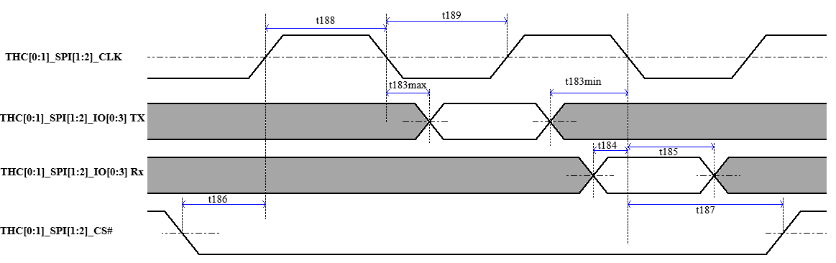
Figure 1 THC SPI timings
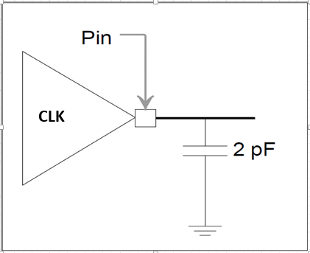
Figure 2

Platform requirements
Platform requirements a.k.a. PRDs for THC SPI are indicated in 1. General Guidelines and BKMs document.
BIOS Requirements
There are no specific BIOS requirements for THC SPI. Settings to configure THC SPI are on BIOS by default.
Common test plan
THC SPI shares the same PRQ methodology as any other GPIO interface.
THC SPI test plan structure from A0 PO to PRQ is defined below. It can be used as a base.
- PO
  - Register access and recipe check for Phy and controller side.
  - Interface enabling.
  - SIV spot check.
- Ax Execution:
  - Broad testing
    - Spec compliance test across at max frequency and POR topology at nominal conditions.
    - At least 5 Broad Distribution units are recommended.
    - Worst case identification test across 5 VT corners at max frequency under POR topology.
    - ES0, ES1, and ES2 milestones can be elaborated with this data.
  - Deep testing
    - Spec compliance test across worst-case VT corner + PPSM units
    - Process coverage recommended is ±3σ TG and TnG. 3 units in each corner, 12 units total has been a good number.

Testing Methodologies/Procedures
THC SPI’s most common test methodology is with functional content. Usually, a BKM to enable THC SPI is provided. There are two ways to validate THC SPI with functional content, on Windows OS or directly on the EFI menu enabling the Virtual Keyboard.
***Insertar como habilitar el virtual keyboard***
THC SPI can also be validated with synthetic content. This content can be found in the current PythonSV project folder. I.E. C:\PythonSV\lunarlake\vjt\thc\PIO_ReadWrite_PostSi_THC0.py.
Adjustments to PIO_ReadWrite_PostSi_THC0.py should be done to configure THC SPI frequency and modes.
To run THC SPI synthetic content:
- From lunarlake.vjt.thc. PIO_ReadWrite_PostSi_THC0 import *
- PIO_Read(Address,ByteCountRead)
  - PIO_Read(0x0,8)
- PIO_Write(Address,ByteCountWrite, Write_Value = 0x12345678)
  - PIO_Write(0x0, 4, 0x123465789)
With the above lines, SPI transactions should be seen on the oscilloscope, for all signals. Even this is synthetic content the end device should answer, and Rx signals should be toggling.
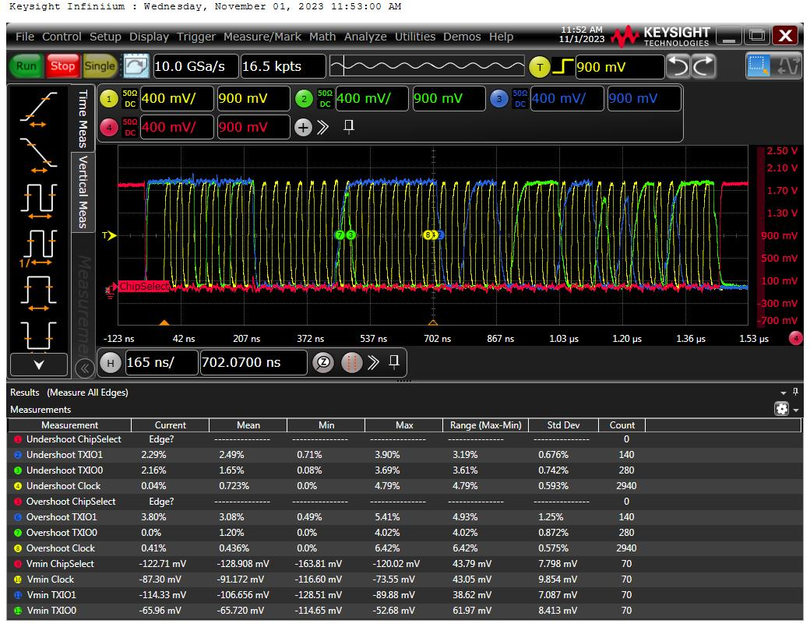
Figure 3 Example of THC SPI waveform for IO0 and IO1

Trigger
The most common type of trigger for THC SPI is “Pulse Width” and CS signal as the source. This is because with this trigger is easy to identify the frame to measure and more accurate avoiding catching a not wanted frame.
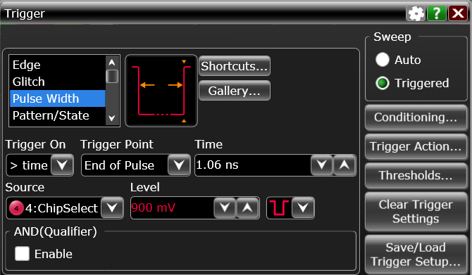
Figure 4 Pulse Width trigger on CS signal

Automation
The automation used to validate ISH SPI is the same used to validate most WBIO client interfaces: Dragon.
Dragon automation is located at https://github.com/intel-restricted/frameworks.validation.wideband-io.flows and documentation to use Dragon can be found on the Wiki tab.
Topologies
Historically the only topology for ISH SPI is 1-Load (Add-In Card) Topology.
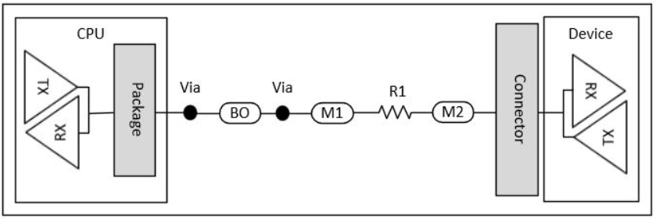
Figure 5 ISH-SPI 1-Load (Add-In Card) Topology

Endpoint/devices
The main device for ISH SPI validation is the MosAIC (Modular Sensor Add-In Card) SPI Sensor.
When using both synthetic and functional content the test point is directly on the SPI sensor pins that is mounted on the MosAIC.
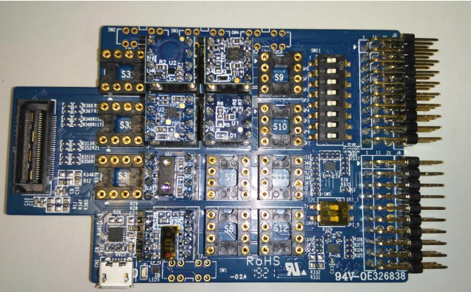
Figure 6 MosAIC

Tools and Equipment
This is the list of Tools and Equipment needed to perform ISH SPI Electrical Validation
- Oscilloscope
- Test Probes
Oscilloscope
MSO9254A Oscilloscope can be used to perform ISH SPI measurements.
Characteristics: 16GHz, 20GS/s
Test Probes
4 x N2496A Probes are recommended to perform ISH SPI electrical validation.
Characteristics: Single Ended 2GHz Active Probe

